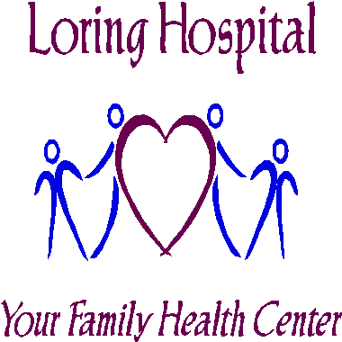

**COVID-19 and Surgical Procedures: A Guide for Patients**

The country is responding to a new virus known as Coronavirus Disease 19 or COVID-19. COVID-19 rapidly spreads from person-to-person contact and is also transmitted as it can stay alive and contagious for many days on surfaces. COVID-19 has resulted in our hospitals and health care system being strained by the number of critically ill people.

**Why do I need COVID-19 testing prior to my procedure?**

In order to determine if your procedure should continue as scheduled, we need to know if you are COVID-19 positive. There have been, at times, patients that are positive for COVID-19 without symptoms. The test results will be called to you as they become available by your family physician. We will continue with all pre-op education and testing as normal with the addition of a COVID-19 nasal swab.

**Is COVID-19 testing covered by my insurance?**

During the COVID-19 Pandemic this test will be covered by insurance.

**What do I do after my COVID-19 testing?**

In order to have this elective procedure, we will need you to self-isolate/quarantine from the time you leave the testing site until the time you enter Loring for your scheduled procedure.

**What does self-isolation/quarantine mean?**

* Stay home and do not go to school, public areas or attend gatherings.
* Do not use public transportation, ride sharing or taxis.
* Postpone all travel.
* Wash your hands often and practice good hygiene.
* Postpone all non-essential medical appointments until you have completed your procedure.
* Do not go to work if you work away from home, if a note is needed to stay home from work you will need to call your family physician.

**What about my family during self-isolation?**

All family members living in the same household as the patient must also quarantine for this duration. If family members are unable to quarantine, patients must isolate away from family in a designated household space.

**What if I develop a fever (>100.0), shortness of breath, sore throat or cough?**

If you develop any fever or symptoms while waiting for your procedure, please notify our surgery department at **1-712-662-7105**.

**Can my family be present at Loring for my procedure?**

The current visiting restrictions at Loring limit all visitors. These restrictions are to assist in limiting exposure to our vulnerable patients. The only visitors allowed for procedures are those needed for direct care of a loved one (example: a parent of a pediatric patient). Please inform the surgery staff if you would like them to give your family a phone call to keep them updated on your status.

**How do I care for myself at home and what precautions should I take?**

Since conditions with respect to the COVID-19 epidemic are rapidly changing follow the current U.S. Centers for Disease Control and Prevention guidelines.2

Follow your dismissal instructions that will be given to you before you are discharged from the hospital after your procedure. Continue to social distance (6 feet), avoid crowds and visitors, and wash your hands frequently for at least 20 seconds. If you have to go out into public wear a mask.

We all hope that this response is temporary. Postponing elective procedures does not mean they cannot be done in the future once COVID-19 decreases. Communication with your health care provider in the interim is key. We can all help to resolve this crisis by following the [CDC](http://www.coronavirus.gov/) [guidelines](http://www.coronavirus.gov/) and the advice of the American College of Surgeons for [elective surgery.](https://www.facs.org/covid-19/clinical-guidance/elective-case)

# References

1. American College of Surgeons. *Guidelines for Triage of Non-Emergent Surgical Procedures.* March 17, 2020. Available at: http[s://www.facs.org/-/media/files/covid19/information-for-](http://www.facs.org/-/media/files/covid19/information-for-) surgeons/triage. Accessed March 31, 2020.
2. Center for Disease Control. *CDC Recommendation: Postpone Non-Urgent Dental Procedures, Surgeries, and Visits.* March 20, 2020. Available at: http[s://www.cdc.gov/oralhealth/infectioncontrol/statement-COVID.html.](http://www.cdc.gov/oralhealth/infectioncontrol/statement-COVID.html) Accessed March 31, 2020.
3. Desai AN, Patel P. Stopping the spread of COVID-19. *JAMA*. Published online March 20, 2020. doi:10.1001/ jama.202.4269. Available at: https://jamanetwork.com/journals/jama/fullarticle/2763533. Accessed March 31, 2020.

*Released May28, 2020*